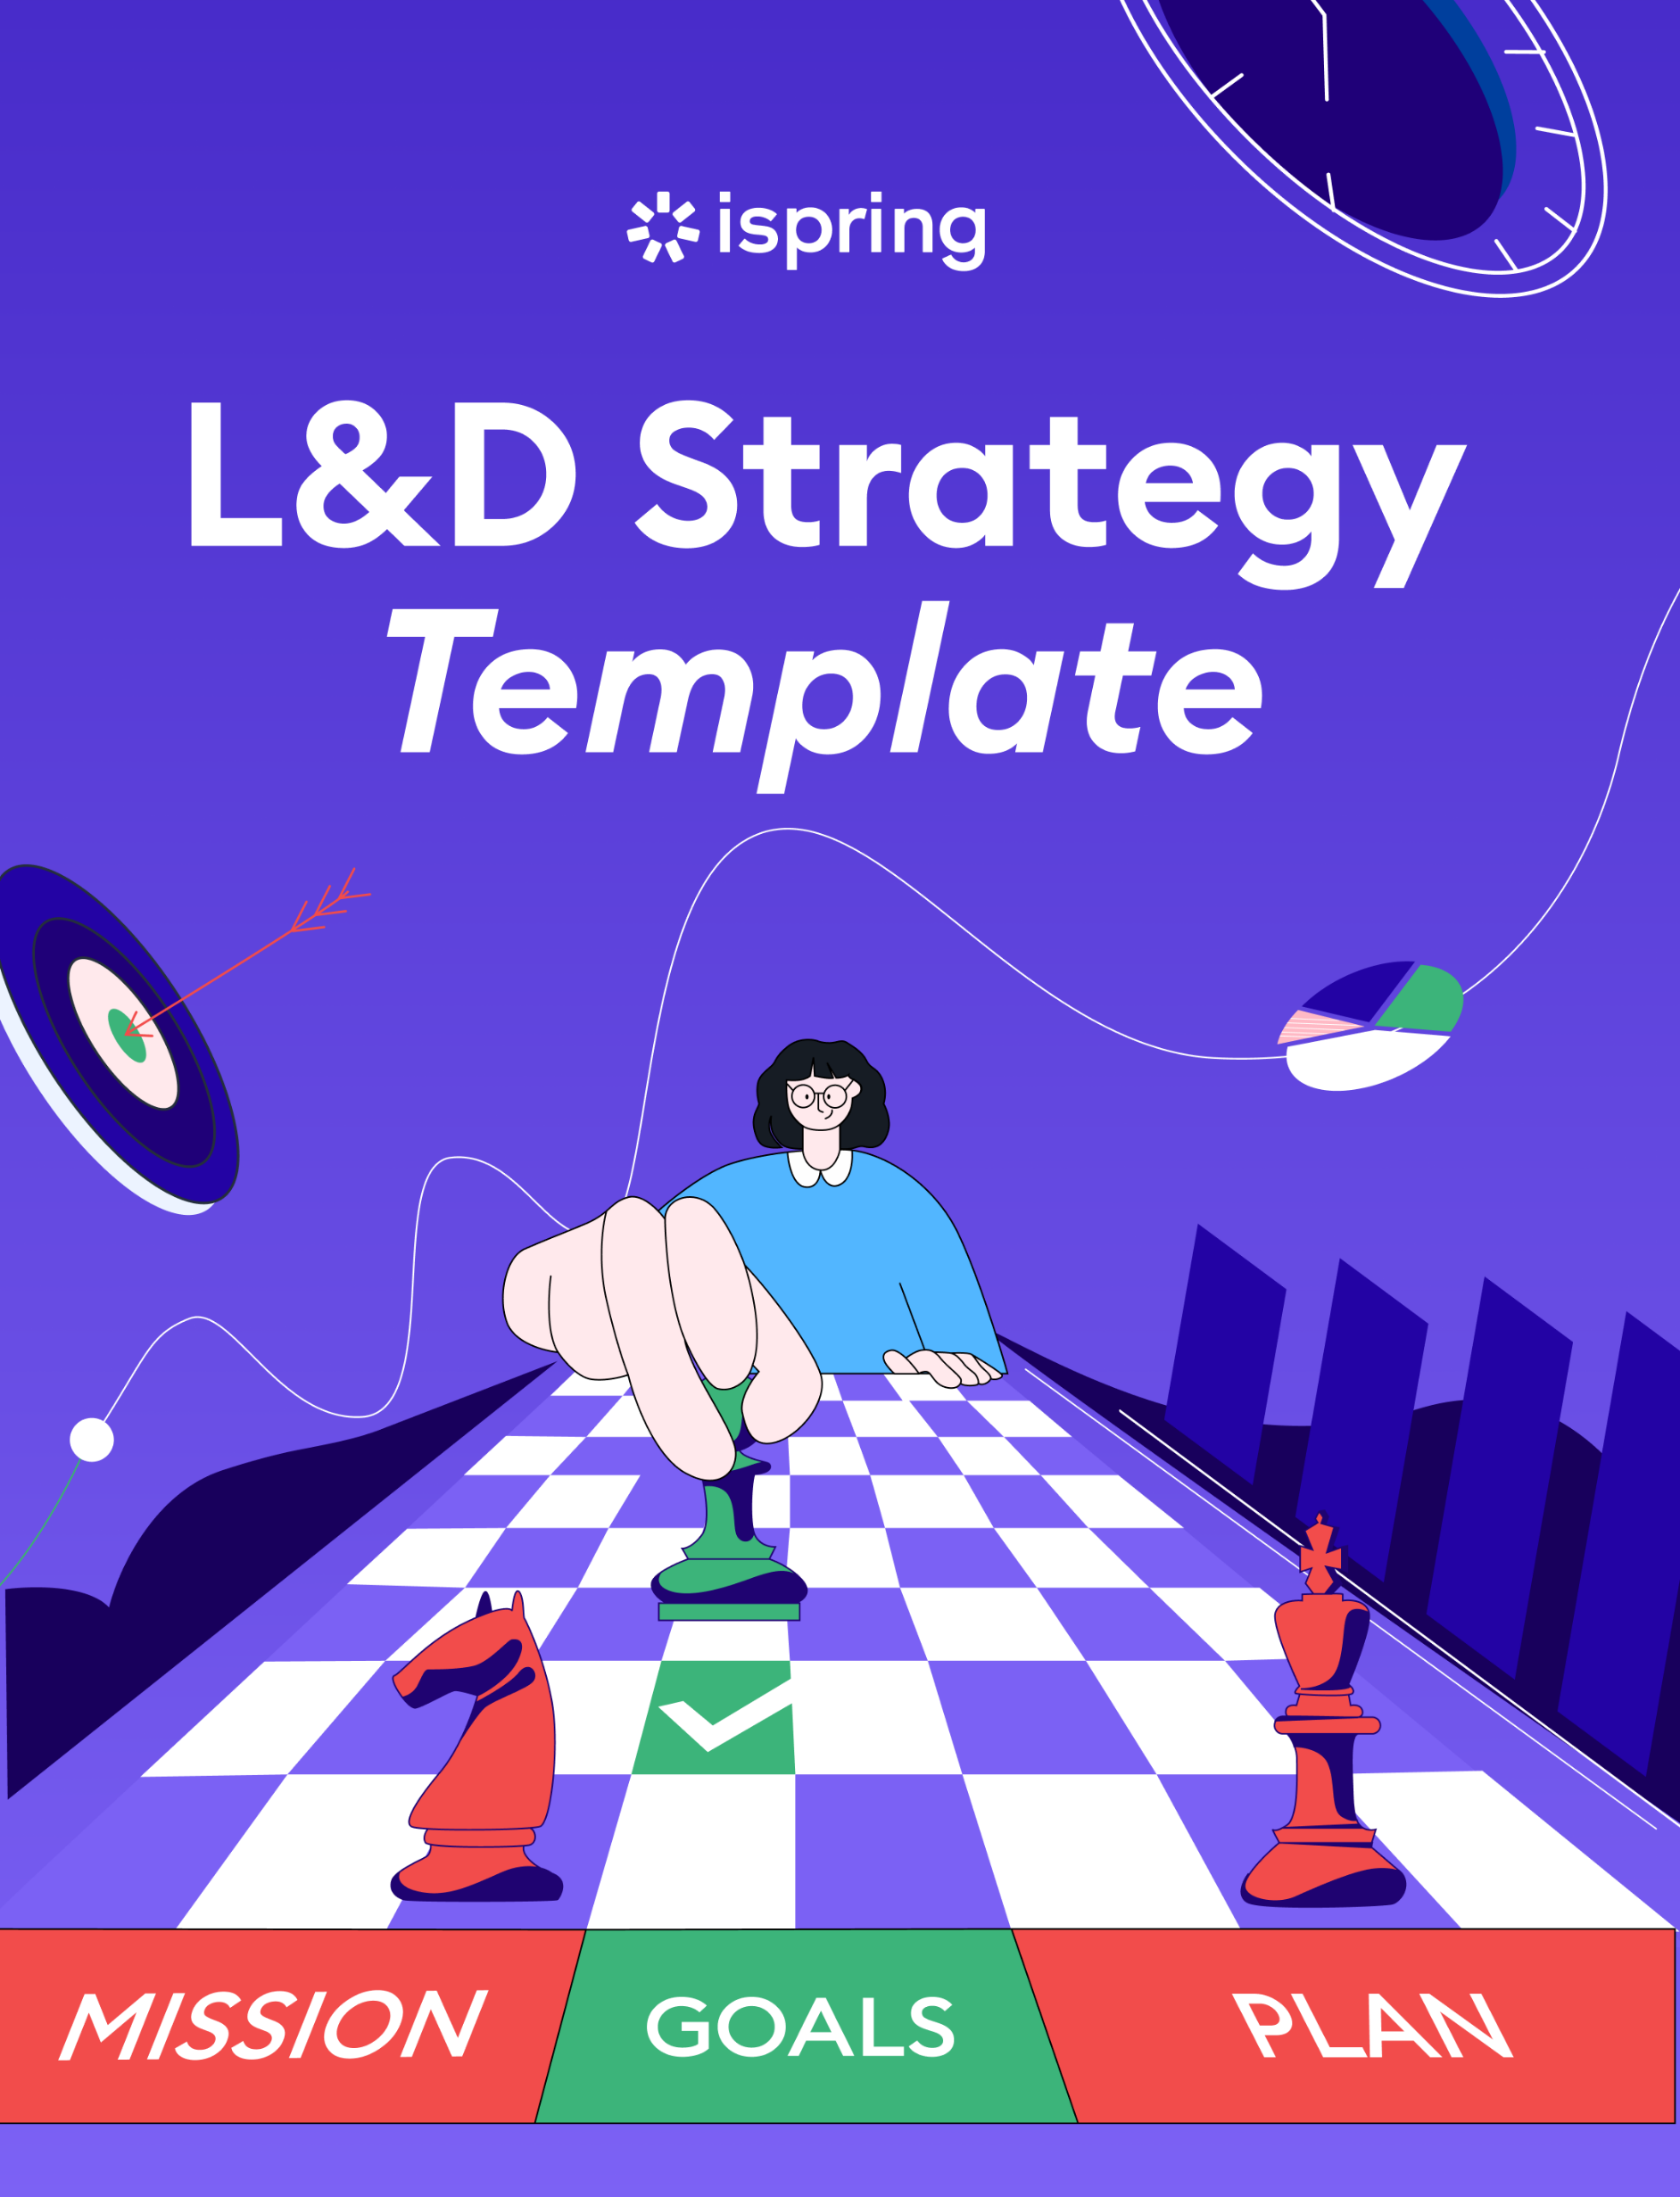

L&D Strategy Template

This template provides a starting point for developing an L&D strategy. Customize it to meet the specific context, needs, and goals of your organization.

Goals and Objectives

Learning  Goals | Define the specific areas of knowledge or skills that the L&D strategy aims to develop  (e.g., leadership, technical skills, or customer service skills).
Learning  Objectives | Set measurable objectives aligned  with business needs and employee development.

Organizational Analysis

Business Goals | Define key business objectives and specify how L&D can contribute to reaching them.
Workforce Assessment | Evaluate employees’ current skill levels, knowledge, and training needs.  Download our comprehensive training needs analysis template.
Skill Gaps | Identify skill gaps, ranking them by the priority of filling them.  Download our in-depth skill gap analysis template.

Vision and Mission

Vision  Statement | Define the organization’s long-term vision  for employee learning and development.
Mission Statement | State the purpose and guiding principles  of the L&D strategy.

Training and Development Initiatives

Program Overview | Provide an overview of the training  and development initiatives to be implemented.
Training  Methods | Specify the delivery methods to be used  for each program, such as classroom training, eLearning, on-the-job training, virtual classrooms, mobile learning, or workshops.
Content  and Curriculum | Lay out the topics, modules, and learning materials  to be included in the training programs.
Resources  and Support | List the resources, tools, and support needed  to realize effective training experiences.

Implementation Plan:

Timeline | Outline a timeline with key milestones and deadlines for each training initiative (include time allocated for adjustments).
Responsibilities | Assign roles and responsibilities to all stakeholders (HR, L&D, managers) involved in the implementation process.
Budget | Estimate the budget for each training initiative, including costs for eLearning tools, instructors,  and course authors.

Evaluation and Measurement:

Evaluation Methods | Define the evaluation methods and metrics that  will be used to measure the effectiveness of the training initiatives (pre and post-training assessments, learner feedback, etc.).
Continuous Improvement | Outline strategies for using evaluation results  to improve the L&D initiatives.

Stakeholder Engagement:

Communication  Plan | Detail how you will communicate the L&D strategy  to employees, managers, and other stakeholders (emails, all hands events, slack  announcements, etc.).
Continuous Improvement | Determine ways to involve and engage key stakeholders in the design, delivery,  and evaluation of the training programs  (e.g., champion programs).

Welcome to the iSpring Community!

Feel free to join and become a valuable part of a community of instructional designers and eLearning professionals who are taking training to the next level with iSpring.
Blog →  Explore the exciting world  of eLearning together with  our helpful articles and how-tos. | Webinars →  Get eLearning tips and tricks  from top-notch industry experts.
Guides →  Get step-by-step directions on how to create and launch eLearning. | YouTube →  Enjoy weekly eLearning videos  and don’t forget to subscribe.

